Question 4:

Troubleshoot Ethernet Communication with ping and traceroute -> Using cisco packet tracer

Approach

First create a network with Min of two PC’s and one switch and one router. Configure the router. Give a name, Security code, Password, virtual password, and finally give ip to the port you connected your switch.

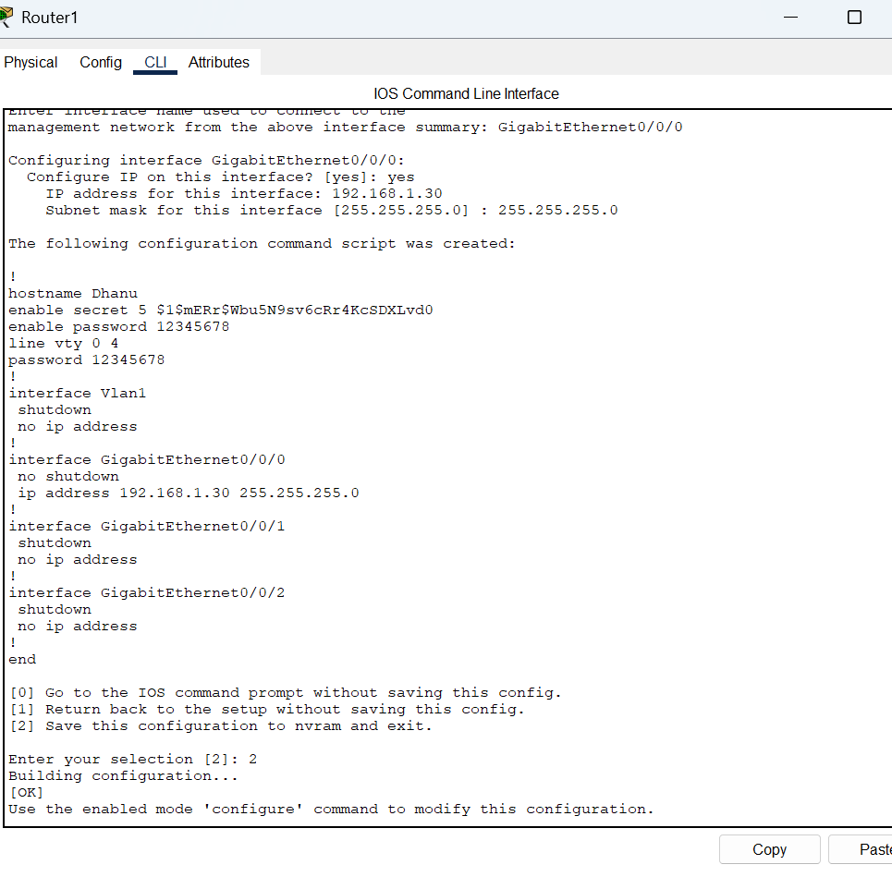

Once done assign IP for pc’s as well. Make sure that the PC are all on same class of router.

Once done try to ping the router from the pc. If the ping was successful then the connection is successfully.

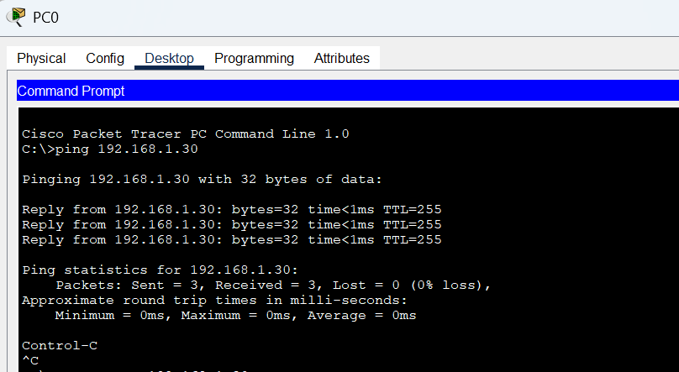

Now try traceroute command to check the number of hops the message passing through.

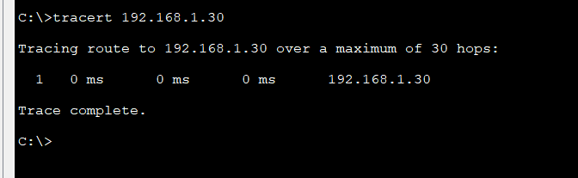

In one of my assignment I mentioned that 30 is a random number. But I get to know that 30 is maximum hops allowed. Here Our packet passed though one hop that is router. We don’t have intermediate router for communication.

Here I attached my mac address table of the switch

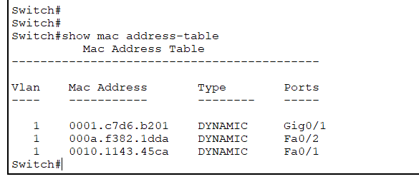

Possible Problems

* Request timed out
* packets take multiple hops or get stuck

Troube Shooting:

* + Check Physical Connections
  + Go to Router CLI and check if the Ethernet interface is up
    - show ip interface brief
  + If it shows administratively down, enable it
    - configure terminal
    - interface FastEthernet0/0
    - no shutdown
    - exit
  + Check if all ip falls under same class
  + Check whether the ip route has the router’s ip. If not add a route
  + Still error after adding route try to restart the networkmanager